**Research**

**YNAB**

**Introduction to YNAB (You Need a Budget)**

YNAB (You Need a Budget) is a powerful budgeting application designed to help users take control of their finances, eliminate debt, and build financial stability. Unlike traditional budgeting tools that focus on tracking past expenses, YNAB uses a proactive, zero-based budgeting approach that encourages users to assign every dollar a job, ensuring their money is working efficiently toward their financial goals(Kathy Yakal. 2024).

With its user-friendly interface, real-time syncing across devices, and educational resources, YNAB makes it easy to track spending, adjust budgets dynamically, and develop better financial habits. Whether you're looking to break the paycheck-to-paycheck cycle, save for a major purchase, or plan for the future(Kathy Yakal. 2024)., YNAB provides the tools and strategies to achieve lasting financial success.

**OVERVIEW**

This app is a budgeting app designed to help users take control of their finances through the zero-based budgeting method. It emphasizes active participation in money management by assigning every dollar a specific purpose, ensuring that income aligns with expenses and savings goals. The app requires regular interaction, including manually recording transactions or syncing accounts for automatic updates. It offers tools for detailed financial tracking but lacks features like cost-cutting suggestions or investment tracking

YNAB operates on four core principles:

1. **Give Every Dollar a Job**: Allocate funds to categories like rent, groceries, or savings until no money is left unassigned.
2. **Embrace Your True Expenses**: Break down large, irregular costs (e.g., vacations) into manageable monthly allocations.
3. **Roll With the Punches**: Adapt budgets dynamically to handle unexpected expenses.
4. **Age Your Money**: Build savings to increase the time between earning and spending.

**Strengths of YNAB Budgeting App**

1. **Comprehensive Budgeting Method**: YNAB uses the zero-based budgeting approach, which requires assigning every dollar a job, ensuring that users are fully engaged with their financial planning.
2. **Multi-Device Accessibility**: The app is available on various platforms, including web, mobile, and smartwatch apps, allowing users to manage their finances anywhere.
3. **Visual Tracking**: YNAB provides clear visualizations of spending categories, making it easy to monitor budgets and identify areas for adjustment.
4. **Shared Access**: Users can share their subscription with up to five people, facilitating household budgeting.
5. **Educational Resources**: YNAB offers educational content to help users improve their financial literacy.

**Weaknesses of YNAB Budgeting App**

1. **Steep Learning Curve**: The app requires a significant amount of manual work and time to fully understand and utilize its features effectively.
2. **Cost**: YNAB is one of the more expensive budgeting apps, with no free version available.
3. **Limited Budgeting Methods**: It only supports zero-based budgeting, which may not appeal to users who prefer other methods.
4. **Manual Transaction Management**: Users must manually categorize some transactions and regularly monitor their budgets.
5. **Limited Mobile Reporting**: While the app is robust, some reporting features are more accessible on the web version.

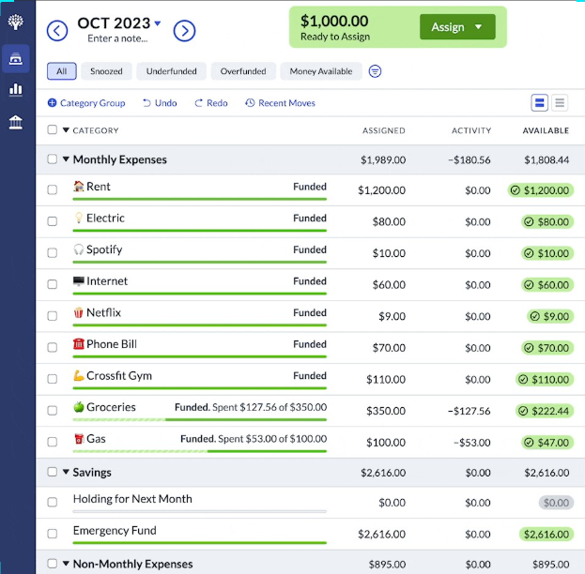

This is how you’re the ynab is going to look like after you add all your expenses and incomes

You can add as many expenses with their cost as you want as it does not limit you

It is very Customizable to your own liking

**Introduction to GoodBudget**

GoodBudget is a user-friendly budgeting app that helps individuals and families manage their finances using the envelope budgeting method. Instead of tracking past expenses, GoodBudget focuses on proactive planning by allocating income into virtual envelopes for different spending categories, ensuring users stay within their budget.

With its intuitive interface, cloud sync across multiple devices, and shared budgeting features, GoodBudget is perfect for couples or families looking to manage their finances together. The app promotes financial discipline, encourages saving, and helps users achieve long-term financial goals by fostering mindful spending habits. Whether you're working toward paying off debt, building savings, or managing monthly expenses, GoodBudget provides a structured and effective way to take control of your finances.

**OVERVIEW**

Goodbudget is a budgeting app based on the envelope budgeting system, offering a digital alternative to the traditional cash-based method. The app allows users to allocate their income into virtual "envelopes" for specific spending categories, such as groceries, rent, or entertainment. Once an envelope is depleted, users must reallocate funds from other envelopes or wait until the next budgeting cycle. This hands-on approach encourages disciplined spending and financial awareness.

Goodbudget offers both free and premium tiers. The free version includes up to 10 envelopes and basic features, while the premium version provides unlimited envelopes, accounts, and device syncing across up to five devices. Users can manually input transactions and balances since Goodbudget does not sync directly with financial institutions.

What sets Goodbudget apart is its simplicity and focus on collaborative budgeting. It allows budget sharing among family members or housemates, making it ideal for managing household finances. Additionally, it offers educational resources like courses, podcasts, and forums to support users in achieving financial goals. While its lack of automatic transaction syncing may require more manual effort, Goodbudget excels in promoting transparency and intentional spending

**Strengths of Goodbudget App**

1. **Envelope Budgeting System**: Goodbudget uses a digital version of the traditional envelope budgeting method, which is intuitive and helps users manage expenses by allocating funds to specific categories.
2. **User-Friendly Interface**: The app is designed to be easy to use, making it accessible to users of all technical backgrounds.
3. **Manual Transaction Management**: Users can manually input transactions, providing a hands-on approach to budgeting and helping them stay engaged with their financial decisions.
4. **Security**: Goodbudget uses 256-bit bank-grade encryption and does not connect to financial accounts, ensuring data security.

**Weaknesses of Goodbudget App**

1. **Manual Data Entry**: The app requires users to manually update transactions, which can be time-consuming and prone to errors.
2. **Limited Automation**: Unlike some other budgeting apps, Goodbudget does not automatically sync with financial institutions, which may be inconvenient for users who prefer automated tracking.
3. **Limited Features**: Goodbudget focuses primarily on budgeting and does not offer additional features like investment tracking or bill payment reminders.
4. **Limited Historical Data in Free Version**: The free version only provides one year of budget history, which may not be sufficient for long-term financial planning

This is the first page you look at and it is nice and simple to navigate around

It had a icon of the app and its message

If you had an account, you just log in but if it’s the first time, you just create a new one so you can use the app

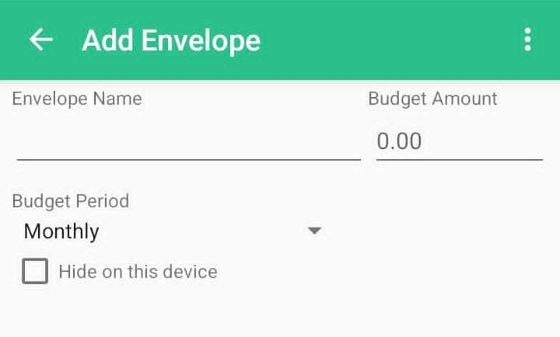

Here is where you add your incomes and expenses

You can also add the amount and if where you can do it on a monthly period or annually

Here is where you set your budget for everything you’ll be including in the budgeting process.

**Introduction to Wallet: Budget Planner & Tracker**

Wallet: Budget Planner & Tracker is a powerful personal finance app designed to help users gain control over their money, track expenses, and plan for financial goals. With real-time expense tracking, automatic bank synchronization, and insightful financial reports, Wallet enables users to make informed spending decisions and build better financial habits.

The app supports multi-currency transactions, shared budgeting with family or partners, and detailed analytics to provide a clear overview of income and expenses. Whether you're looking to save for a major purchase, reduce debt, or simply manage your monthly budget more effectively, Wallet offers the tools and flexibility needed to stay financially organized and achieve long-term financial stability.

**OVERVIEW**

The Wallet: Budget Planner & Tracker app is a leading personal finance tool designed to simplify money management and help users achieve financial stability. Developed by BudgetBakers, it offers a comprehensive suite of features that cater to various financial needs, including budgeting, expense tracking, and financial goal setting.

**Core Features:**

* **Automatic Bank Synchronization:** Wallet integrates with over 4,000 banks worldwide, allowing users to automatically sync transactions across accounts, currencies, and investments. This eliminates the need for manual tracking and ensures real-time updates[1](https://apps.apple.com/ca/app/wallet-money-budget-planner/id1032467659).
* **Flexible Budgeting:** Users can create one-time or recurring budgets tailored to specific categories. The app provides tools to monitor spending and track progress against financial goals[1](https://apps.apple.com/ca/app/wallet-money-budget-planner/id1032467659).
* **Insightful Reports:** Wallet generates visually appealing charts and detailed reports that offer actionable insights into spending habits, cash flow, debts, and net worth. These features empower users to make informed financial decisions[1](https://apps.apple.com/ca/app/wallet-money-budget-planner/id1032467659).
* **Stock Tracking:** The app allows users to monitor their stock portfolios alongside other assets, providing a holistic view of their net worth.

Wallet stands out for its user-friendly design and robust functionality. It simplifies financial planning by automating tasks like transaction categorization and expense tracking. Whether you’re saving for short-term goals or planning decades ahead, Wallet helps you stay in control of your finances from day one(Niketan Sharma,2023)..

Ideal for individuals seeking clarity in their financial life, Wallet combines ease of use with powerful tools to promote long-term financial health.

**Strengths**

1. **Comprehensive Features**: The app offers budgeting, expense tracking, financial goal setting, and even stock portfolio tracking, making it a versatile tool for personal finance management.
2. **Bank Synchronization**: Wallet supports integration with over 4,000 banks globally, enabling automatic transaction tracking and categorization, which saves time and reduces manual effort.
3. **Detailed Reports**: Users can access insightful reports and charts to analyze their spending habits, cash flow, and net worth, aiding in informed financial decision-making.
4. **Customizability**: Wallet allows users to create personalized categories, budgets, and templates, offering flexibility in financial planning.

**Weaknesses**

1. **Data Synchronization Issues**: Some users report persistent problems with syncing data between devices, particularly between mobile apps and the web platform. This can disrupt financial tracking for premium users[1](https://apps.apple.com/us/app/wallet-daily-budget-profit/id1032467659).
2. **Limited Free Version**: The free version restricts features like the number of accounts users can track, pushing many to opt for paid plans[2](https://beebom.com/wallet-app-by-budgetbakers-review/).
3. **Dependency on User Commitment**: Like most budgeting apps, Wallet requires consistent user engagement to be effective. Lack of commitment can lead to underutilization of its features.
4. **No Behavioral Insights**: While the app highlights spending patterns, it does not address underlying financial behaviors or provide guidance on improving them.

Here is where you set you account and the income more, you’ll be having for the expenses you are going to have.

Here is where you get to create your budget, where you will be add the categories that will occur monthly or year and the amount of money it will cost

And under it is where you will be getting you goals for every month and even monthly goals of how much you want to save

Here is where you put all you expenses for the budget you are creating. It has Name, Period, Amount of money for everything you’ll need.

Innovative Features in Each App

**YNAB (You Need a Budget)**

1. **YNAB Together**: This feature enables collaborative budgeting by allowing multiple users to share a subscription and manage finances as a group, ideal for families or partners.
2. **Loan Planner**: A tool that helps users optimize debt repayment by calculating interest savings and timelines for extra payments, making debt management more strategic.
3. **Customizable Views**: Users can tailor their budget categories to focus on what matters most, enhancing personalization and clarity in financial tracking.

**Wallet: Budget Planner & Tracker**

1. **Bank Synchronization**: Wallet connects to over 4,000 banks globally, automatically importing and categorizing transactions for effortless financial tracking.
2. **Stock Portfolio Integration**: The app includes stock tracking alongside other financial accounts, offering a holistic view of personal wealth management.
3. **Flexible Budgeting Options**: Users can create one-time or recurring budgets across various categories, accommodating diverse financial goals and needs.

**Goodbudget**

1. **Digital Envelope System**: Goodbudget innovates the traditional envelope budgeting method by digitizing it, allowing users to allocate funds to virtual envelopes for specific spending categories.
2. **Collaborative Budgeting Across Devices**: Budgets sync in real-time across multiple devices, enabling shared financial management among family members or partners.
3. **Expense Tracking Reports**: The app provides detailed reports on spending patterns, helping users identify trends and adjust their budgets effectively.

**Project Plan**

YNAB (You Need a Budget)

1. **Goal Tracking**: YNAB allows users to set and track spending and savings goals, providing a clear view of progress towards financial objectives.
2. **Automatic Transaction Import**: Users can securely link their bank accounts to import transactions automatically, streamlining budget management.
3. **Debt Management Tools**: The app includes a loan planner tool to help users manage debt effectively by calculating interest and time saved with extra payments.

Wallet: Budget Planner & Tracker

1. **Automatic Bank Updates**: Wallet connects to over 3,500 banks worldwide, automatically syncing transactions and categorizing them for easy tracking.
2. **Insightful Reports**: The app provides detailed financial reports across accounts, debts, and cash, offering actionable insights into spending habits.
3. **Stock Tracking**: Users can monitor their stock portfolio alongside other financial assets, helping to build a diversified wealth strategy.

Goodbudget

1. **Envelope Budgeting System**: Goodbudget uses a digital version of the traditional envelope budgeting method, helping users manage expenses by allocating funds to specific categories.
2. **Collaborative Budgeting**: The app allows users to share budgets across devices, facilitating joint financial management with family or partners.
3. **Manual Transaction Management**: Users can manually input transactions, providing a hands-on approach to budgeting and helping them stay engaged with financial decisions.

**Planning and Design**

**Introduction**  
PocketPlanner is a modern budgeting app designed to simplify financial management and empower users to take control of their money. It combines intuitive design with powerful features to help individuals track expenses, set goals, and make informed financial decisions. Whether you’re saving for a big purchase, paying off debt, or simply looking to understand your spending habits, PocketPlanner provides the tools to achieve your financial objectives with ease([Niketan Sharma](https://www.nimbleappgenie.com/blogs/author/nimbleappgenie/),2023).

**Overview**  
PocketPlanner stands out as a versatile budgeting solution that caters to both beginners and experienced budgeters. The app offers seamless bank account integration, automatically categorizing transactions for effortless tracking. Its goal-setting feature allows users to create personalized savings plans and monitor progress in real time. PocketPlanner also includes advanced analytics, offering insights into spending patterns and areas for improvement.

What makes PocketPlanner exceptional is its emphasis on automation and customization. Users can set recurring budgets, receive notifications about overspending, and adjust categories based on their unique financial needs. Additionally, the app prioritizes security with bank-grade encryption and multi-factor authentication.

PocketPlanner is ideal for busy individuals seeking convenience without sacrificing control. Its innovative features ensure users stay on top of their finances while fostering long-term financial literacy and stability.

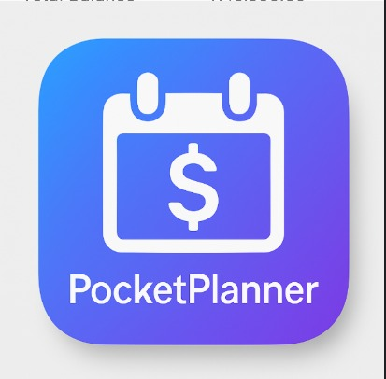

This is the icon and the loading page you see when you get on the app

Here is the login page

Here is where you add the transactions that you will be added in the budget

You can add the names, amount and the dates.

Here is the home page where it shows the total balance you have, the income and the expenses and even have the graphs for the transactions

Here are the transactions that happens, it show you names of your expenses, the money coming in and out and the dates of them

Here is where you edit your profile, manage your account, change currencies and log out of the accounts

This are the features I want for my application

1. **Goal Tracking**: YNAB allows users to set and track spending and savings goals, providing a clear view of progress towards financial objectives.
2. **Automatic Transaction Import**: Users can securely link their bank accounts to import transactions automatically, streamlining budget management.
3. **Collaborative Budgeting**: The app allows users to share budgets across devices, facilitating joint financial management with family or partners.
4. **Manual Transaction Management**: Users can manually input transactions, providing a hands-on approach to budgeting and helping them stay engaged with financial decisions.

**REFERENCE**

1. <https://www.pcmag.com/reviews/ynab>
2. <https://www.mustachianpost.com/ynab-review/>
3. <https://www.cnet.com/personal-finance/banking/ynab/>
4. <https://www.experian.com/blogs/ask-experian/you-need-a-budget-app-review/>
5. <https://www.nimbleappgenie.com/blogs/build-an-app-like-goodbudget/>